
Lab Report
COURSE: CYBER 362
Lab : 1: Install Local Apps
Submitted BY: Rex Kenyon
Date: 09/10/2025
Instructor: Dr. Fusco

Table of Contents
INTRODUCTION 3
SCREEN CAPTURES 4
REFLECTION 11

INTRODUCTION
The purpose of this lab is to prove that python, Conda, VS Code, and Jupyter notebook are setup and running properly. I will demonstrate this by running test provided to me for the purpose of this lab. I will then take screenshots of the results following these test and list them below proving that all of the apps are working properly on my computer.

SCREEN CAPTURES
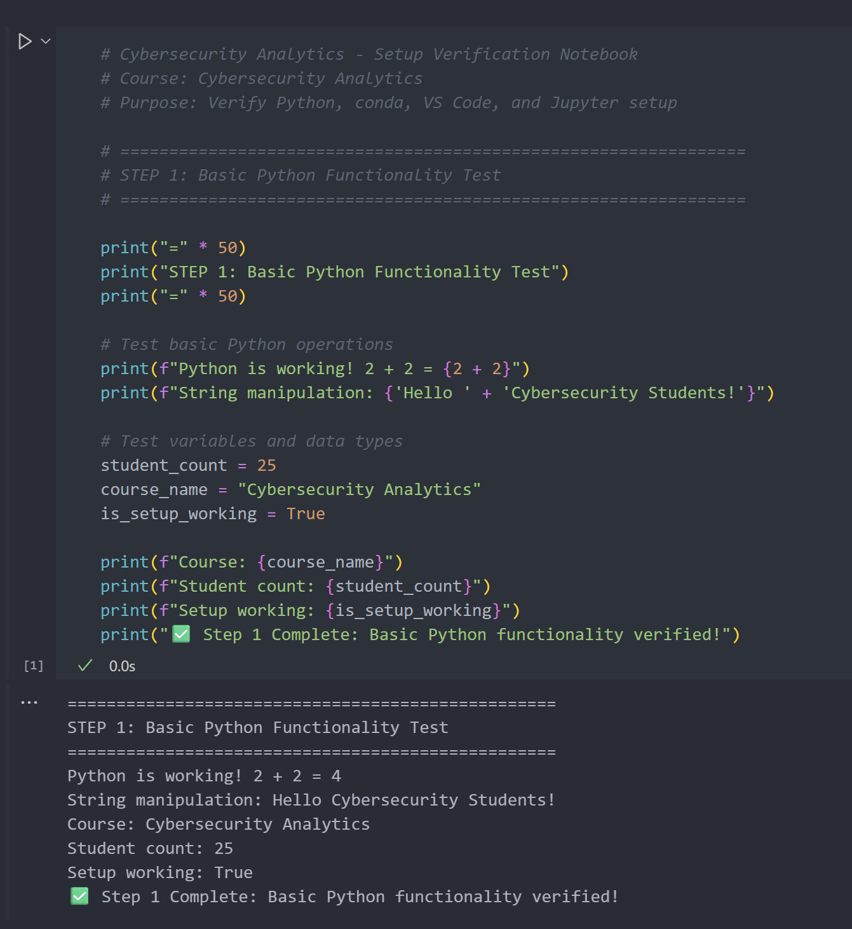
Figure 1 Basic Python Functionality Test

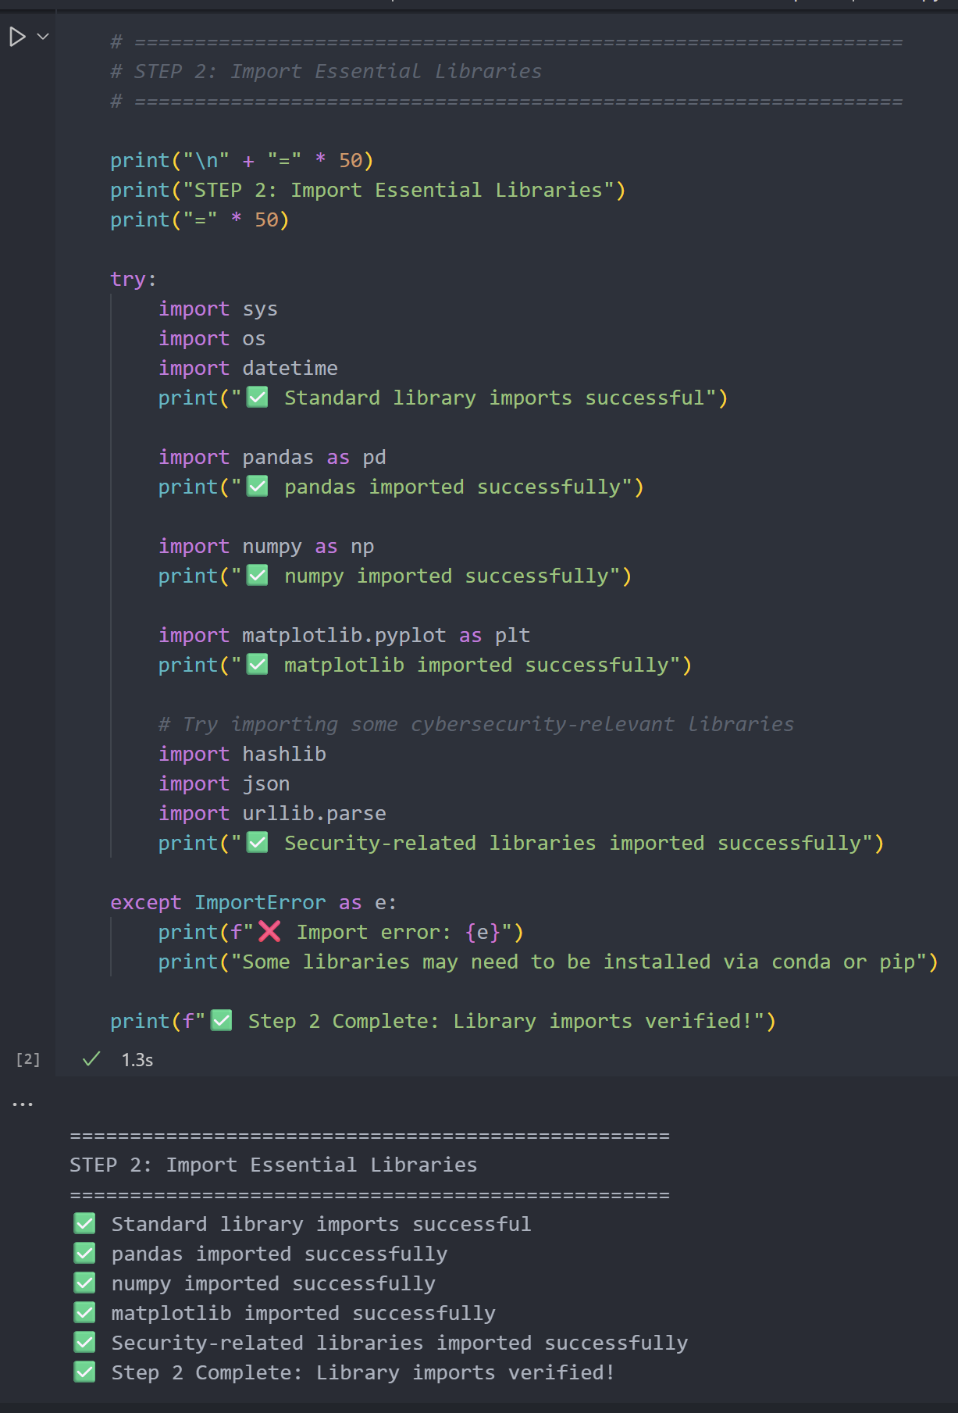
Figure 2 Import Essential Libraries
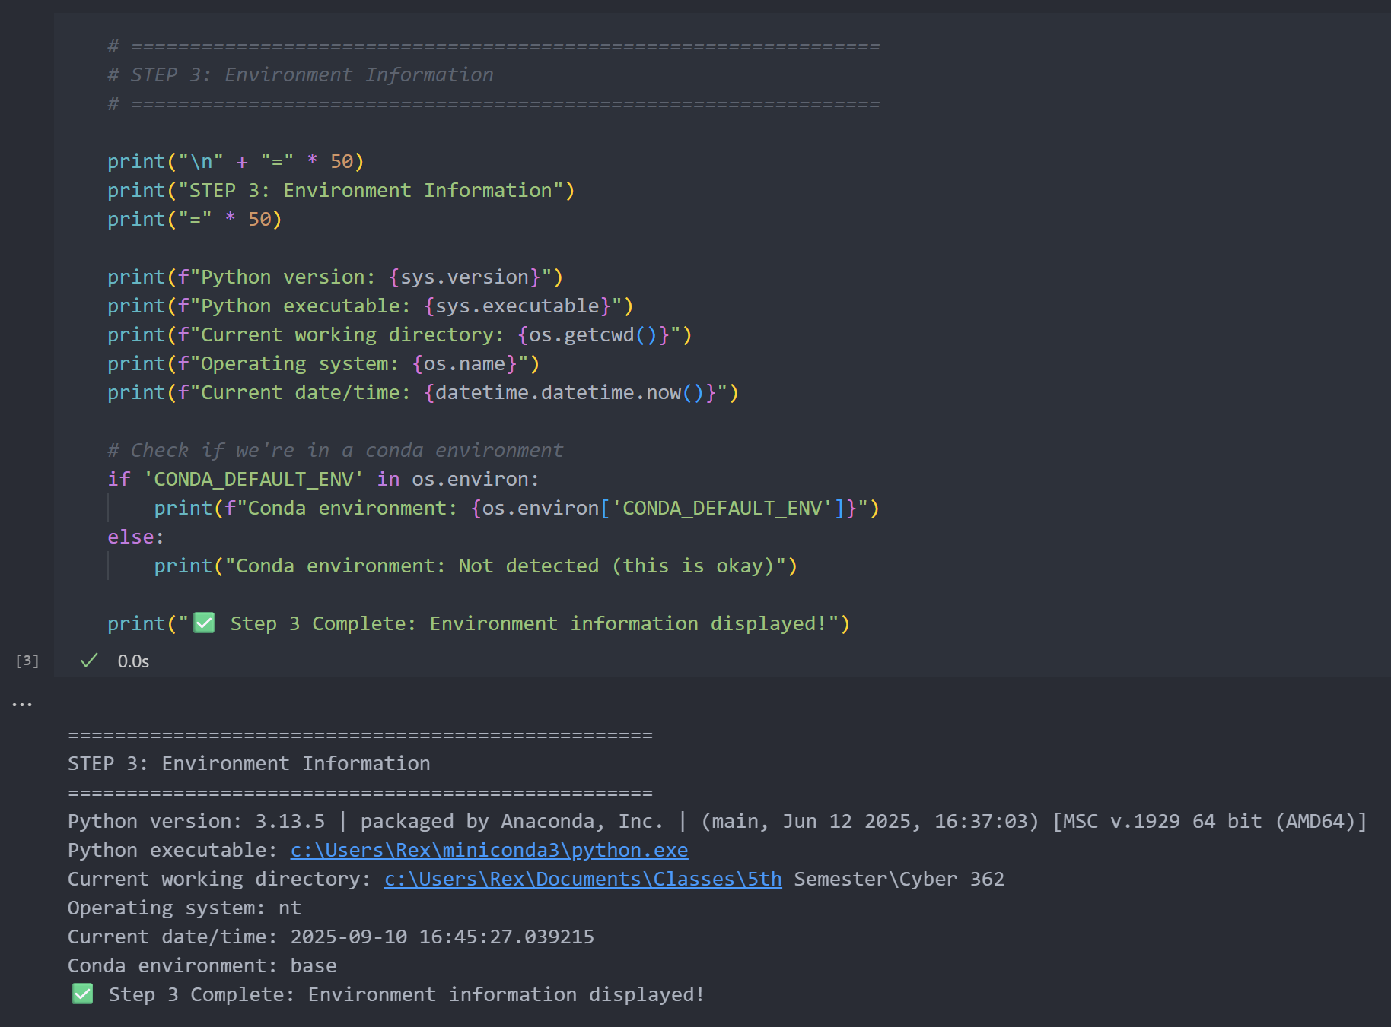
Figure 3 Environment Information
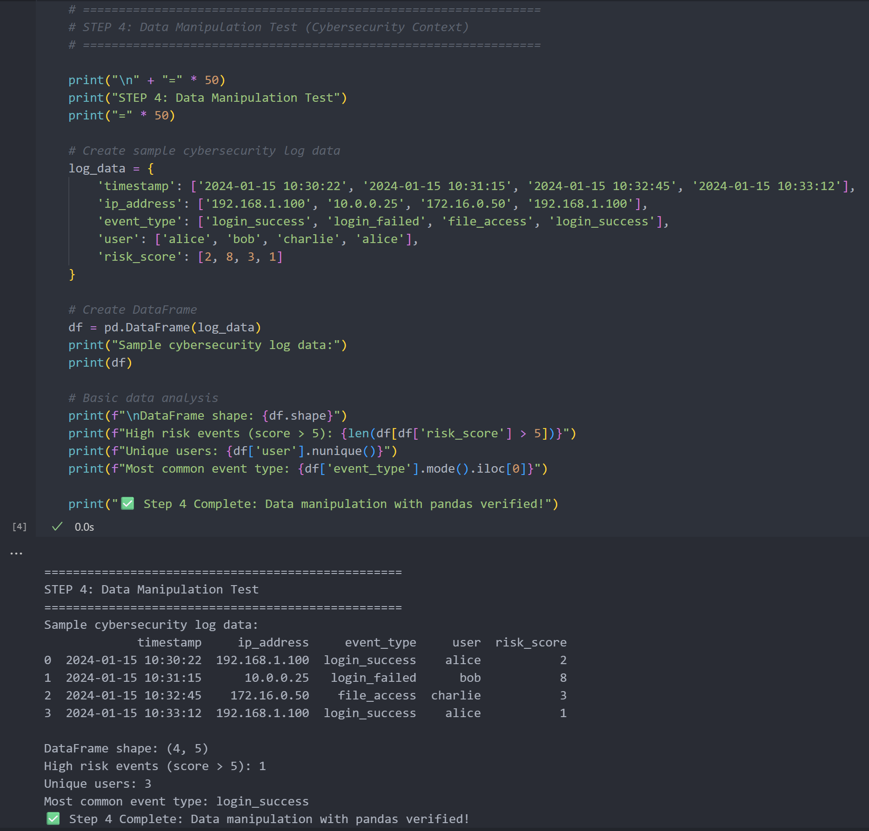
Figure 4 Data Manipulation Test
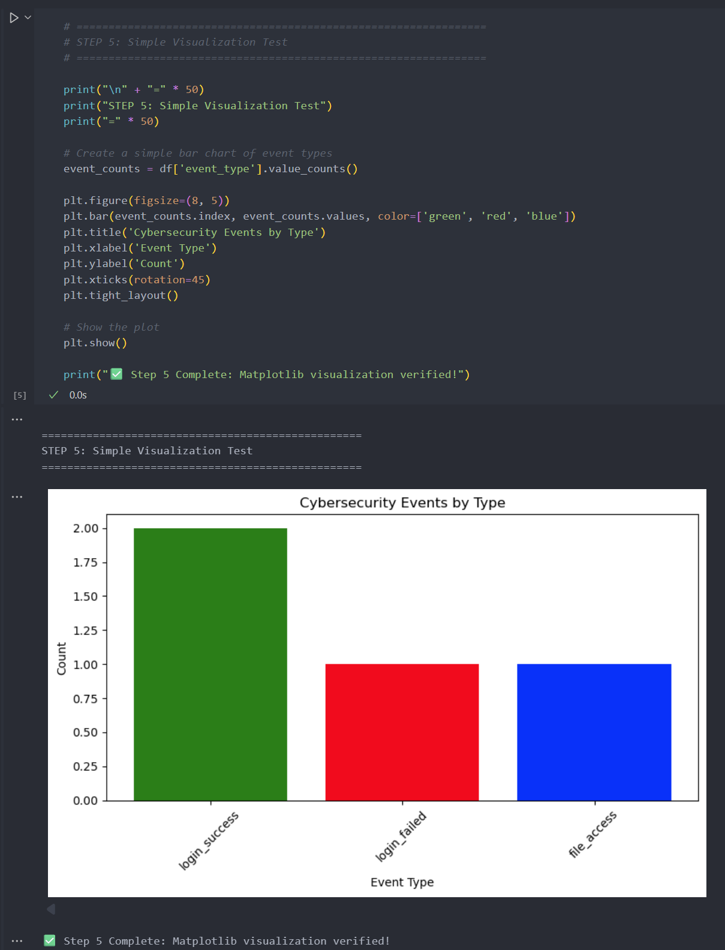
Figure 5 Simple Visualization Test
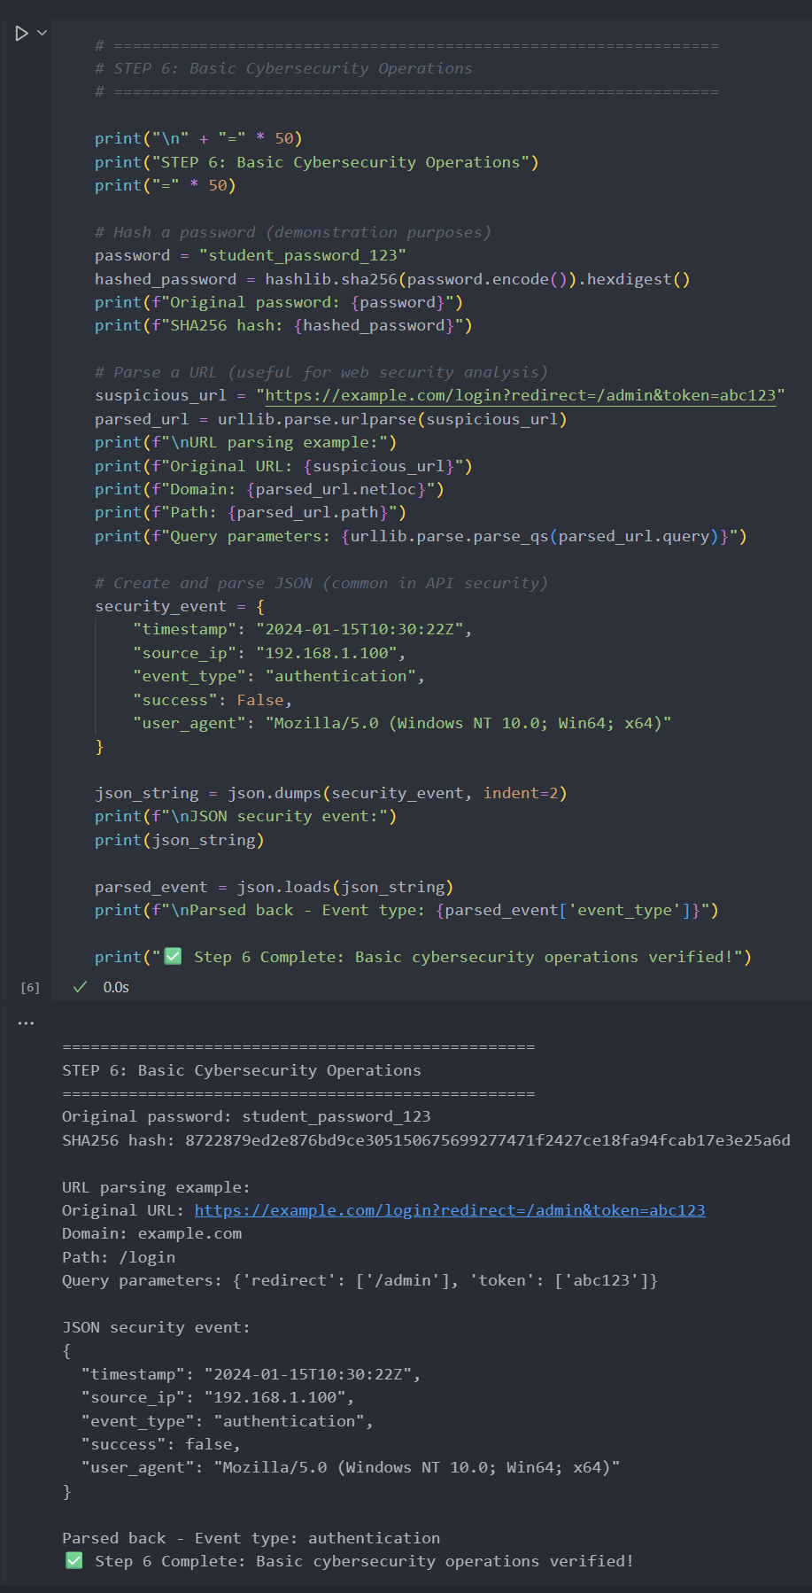
Figure 6 Basic Cybersecurity Operations
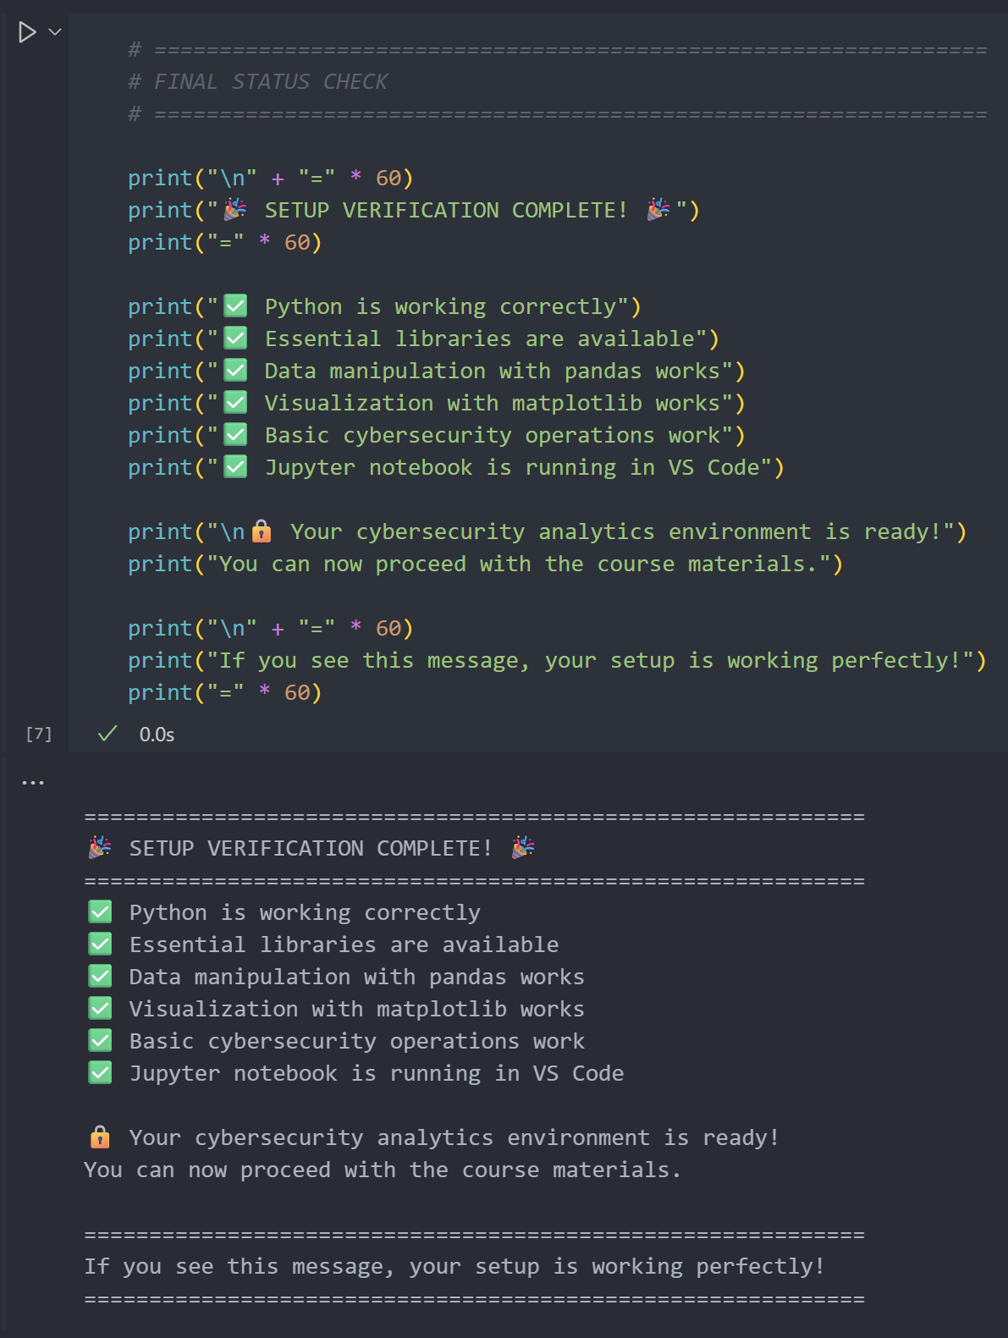
Figure 7 Final Status Check

REFLECTION
This lab was largely review for me as I have worked with Python before, so the code was very familiar. It was interesting to work with jupyter notebook for the first time though. I did have to ask ChatGPT what a cell was and how it works as well as figuring out what the extension for a jupyter notebook was. Overall, this lab did feel pretty easy all though there were times that tested my patience. One of which being when I couldn’t get VS Code to recognize Conda in the terminal. I did a lot of trouble shooting by asking AI for potential solutions. I ended up just restarting my machine and it worked perfectly. This did teach me that sometimes it truly is as easy as turning it off and on again.

